PIZZA SQL QUERIES

KPI’s
- SELECT SUM(total_price) AS Total_Revenue from pizza_sales ##AS used for Temporary colume name
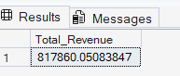

- SELECT * FROM pizza_sales

SELECT SUM(total_price) / COUNT(DISTINCT order_id) as Avg_Order_Value from pizza_sales
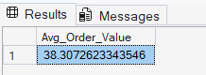

- SELECT * FROM pizza_sales

SELECT SUM(quantity) AS Total_Pizza_Sold from pizza_sales
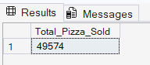

- SELECT * FROM pizza_sales

SELECT COUNT(DISTINCT order_id) AS Total_orders from pizza_sales
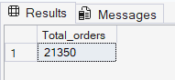

- SELECT * FROM pizza_sales

SELECT CAST(CAST(SUM(quantity) AS DECIMAL(10,2)) / CAST(COUNT(DISTINCT order_id) AS DECIMAL(10,2)) AS DECIMAL (10,2)) AS Avg_Pizzas_Per_oredr from pizza_sales
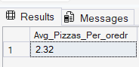

- CHART REQUIREMENT
- SELECT * FROM pizza_sales
--Daily Trend
SELECT DATENAME(DW, order_date) as order_day, COUNT(DISTINCT order_id) AS Total_orders from pizza_sales
GROUP BY DATENAME(DW, order_date)
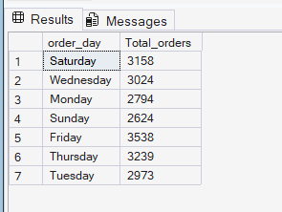

- --Hourly Trend
SELECT DATEPART(HOUR, order_time) AS order_hours, COUNT(DISTINCT order_id) AS Total_orders from pizza_sales
GROUP BY DATEPART(HOUR, order_time)
ORDER BY DATEPART(HOUR, order_time)
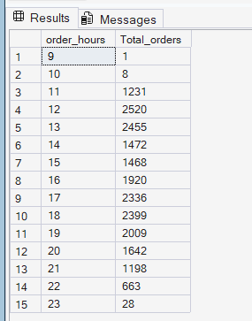
SELECT * FROM pizza_sales
--Daily Trend
SELECT DATENAME(DW, order_date) as order_day, COUNT(DISTINCT order_id) AS Total_orders from pizza_sales
GROUP BY DATENAME(DW, order_date)

--Hourly Trend
SELECT DATEPART(HOUR, order_time) AS order_hours, COUNT(DISTINCT order_id) AS Total_orders from pizza_sales
GROUP BY DATEPART(HOUR, order_time)
ORDER BY DATEPART(HOUR, order_time)

- SELECT * FROM pizza_sales
SELECT pizza_category, sum(total_price) as Total_Sales, sum(total_price) *100 / (SELECT sum(total_price) from pizza_sales WHERE MONTH(order_date) = 1) AS PCT
from pizza_sales
WHERE MONTH(order_date) = 1
GROUP BY pizza_category
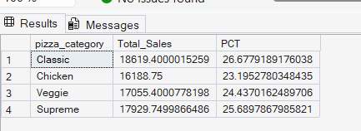

- SELECT * FROM pizza_sales
SELECT pizza_size, CAST(sum(total_price) AS DECIMAL(10,2)) as Total_Sales, CAST(sum(total_price) *100 / (SELECT sum(total_price) from pizza_sales WHERE DATEPART(quarter, order_date)=1) AS DECIMAL(10,2)) AS PCT
from pizza_sales
WHERE DATEPART(quarter, order_date)=1
GROUP BY pizza_size
ORDER BY PCT DESC
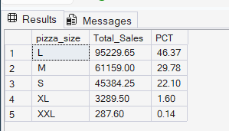
- SELECT * FROM pizza_sales

SELECT pizza_category, sum(quantity) as Total_Pizzas_Sold
from pizza_sales
Group by pizza_category
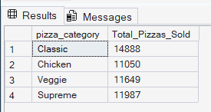
- SELECT * FROM pizza_sales

SELECT TOP 5 pizza_name, sum(quantity) as Total_Pizzas_Sold
from pizza_sales
GROUP BY pizza_name
ORDER BY sum(quantity) DESC
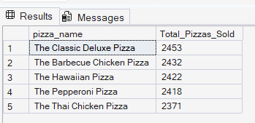

- SELECT * FROM pizza_sales

SELECT TOP 5 pizza_name, sum(quantity) as Total_Pizzas_Sold
from pizza_sales
GROUP BY pizza_name
ORDER BY sum(quantity) ASC
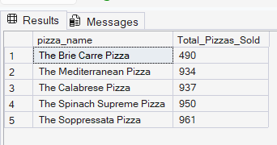
- SELECT * FROM pizza_sales

SELECT TOP 5 pizza_name, sum(quantity) as Total_Pizzas_Sold
from pizza_sales
WHERE MONTH(order_date) = 1 ##1 mean jan 2 mean feb month 12 mean dec month
GROUP BY pizza_name
ORDER BY sum(quantity) ASC
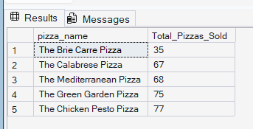

Rohan Jha

